Professor Badari Eswar

CMPE 187

November 12nd, 2017

The goal is to add a new elevator that will cover all floors in the College of Engineering building.

Business Rules:

1. While in Maintenance mode, the elevator will not move
2. Elevator will take passengers to their destination
3. Elevator will fulfill all requests in one direction before switching directions
4. If passenger requests the current floor, doors will open (if not already moving)
5. Passengers are able to request floors from outside and inside the elevator
6. Elevator will be able to do an emergency stop

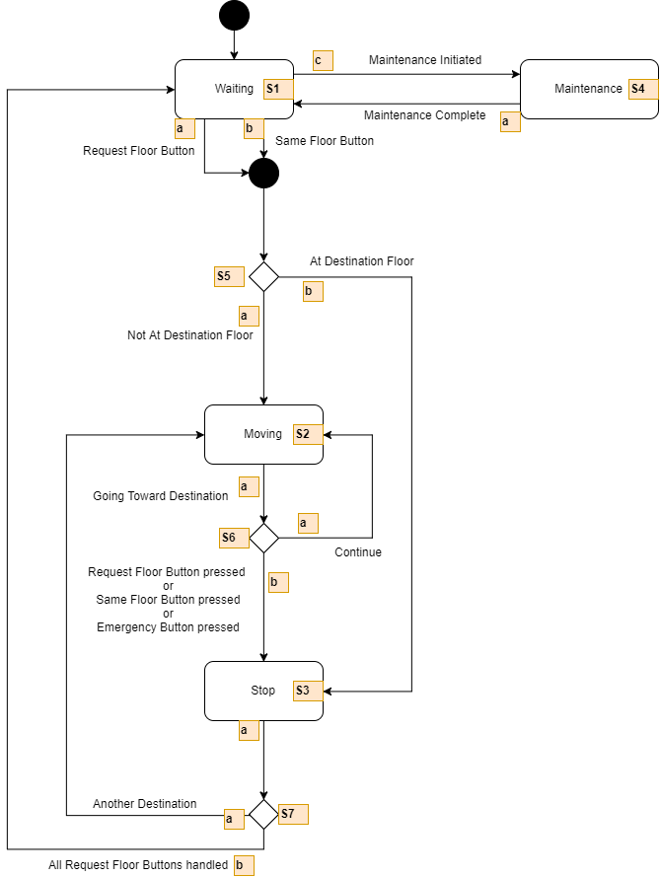

Transition and input table:

|  |  |  |
| --- | --- | --- |
| Input | Symbol | Meaning |
| Request floor button | a | Request a certain floor |
| Same floor button | b | Request current floor |
| Emergency button | b | Stop at the nearest floor |
| Maintenance Initiated | c | Key turned for maintenance (no movement) |

State-Transition Table

|  |  |  |
| --- | --- | --- |
| State-Transition | Symbol | Meaning |
| Waiting | S1 | Waiting for input |
| Moving | S2 | Moving to x floor |
| Stop | S3 | Stop after moving to x floor |
| Maintenance | S4 | Not working for maintenance |
| Floor check | S5 | Checking if in correct floor |
| Check button | S6 | Checking what button was pressed |

Normal Operation Test Cases:

|  |  |  |  |  |  |  |  |
| --- | --- | --- | --- | --- | --- | --- | --- |
| **#** | **Reason** | **Scenario** | **Input** | **Expected** | **Actual** | **P/F** | **Sequence** |
| 1 | Passenger Waiting on Same Floor | User is outside elevator and presses button to wait for elevator. Elevator is already waiting at that floor | Button Press on same floor “x” | Elevator opens door at floor x | Same | P | S1b - S5b - S3a - S7b |
| 2 | Passenger Waiting at Other Floor: uninterrupted | User is outside elevator and presses button to wait for elevator. Elevator is waiting on another floor | Button Press on another floor “x” | Elevator opens door at floor x | Same | P | S1a - S5a - S2a - S6b - S3a - S7b |
| 3 | Passenger Waiting at Other Floor: interrupted | User is outside elevator and presses button to wait for elevator. Elevator is waiting on another floor and needs to make stops | Button Press on another floor “x”  Button Pressed on an in between floor “y” | Elevator opens door at floor y before closing and moving and opening door at floor x | Same | P | S1a - S5a - S2a - S6b - S3a - S7a - S2a - S6b - S3a - S7b |
| 4 | Passenger Inside Requests Another Floor: uninterrupted | User is inside elevator and presses button to go to another floor, elevator is going up or down | Button Press on another floor “x” | Elevator moving to x floor | Same | P | S1a-S5a-  S2a-S6b-  S3a-S7b |
| 5 | Passenger Inside Requests Another Floor: interrupted, elevator already is same direction | User is inside elevator and presses button to go to another floor, elevator is going up or down | Button Press on another floor”x”  Button Pressed on an in between floor “y” | Elevator moving to y floor before to x floor | Same | P | S1a - S5a - S2a - S6b - S3a - S7a - S2a - S6b - S3a - S7b |
| 6 | Passenger Inside Requests Another Floor: interrupted, wait for direction of elevator to change | Elevator must first fulfill all requests in current direction before reversing direction | Button Press on another floor”x”  Button Pressed on an in between floor “y” | Elevator moving to y floor before moving to x floor | Same | P | S1a - S5a - S2a - S6b - S3a - S7a - S2a - S6b - S3a - S7b |
| 7 | Passenger requests an “Emergency Stop” | Elevator will stop at the nearest floor in the current direction it is moving, or at current floor | Button press on “Emergency” button | Elevator is moving either up or down and stop at the next floor in the same direction or will stop at current floor | Same | P | S1a - S5a - S2a - S6b - S3a - S7a - S2a - S6b - S3 |

Exception Test Cases:

|  |  |  |  |  |  |  |  |
| --- | --- | --- | --- | --- | --- | --- | --- |
| **#** | **Reason** | **Scenario** | **Input** | **Expected** | **Actual** | **P/F** | **Sequence** |
| 1 | Maintenance Request Initiated | User has maintenance key, key switches to elevator to maintenance mode | Key turn | Elevator does not take any button pressed until maintenance is done | same | P | S1c |
| 2 | Passenger Inside Requests Floor Elevator is already on | Passenger presses the floor number they are currently on | Button pressed on the same floor | Elevator opens door at floor at current floor | same | P | S1c |

Design for Control Panel:

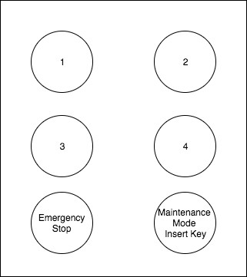

Transition Tour:

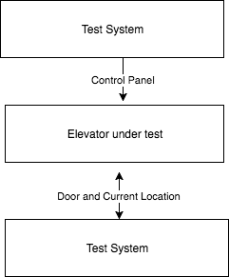

FMS Tour

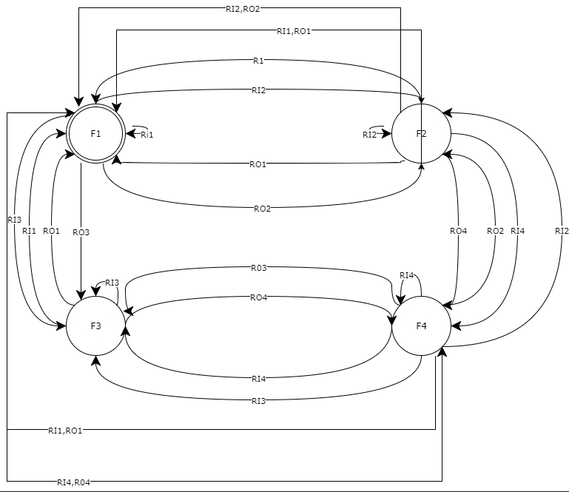

|  |  |  |
| --- | --- | --- |
| Input | symbol | meaning |
| Request input to floor 1 | R1 | Push button to go to floor 1 |
| Request input to floor 2 | R2 | Push button to go to floor 2 |
| Request input to floor 3 | R3 | Push button to go to floor 3 |
| Request input to floor 4 | R4 | Push button to go to floor 4 |
| Request input to floor 2 and 3 | R2, R3 | Push button to go to floor 2 and 3 |

|  |  |  |
| --- | --- | --- |
| Output | symbol | meaning |
| Output to floor 1 | RO1 | Open door at floor 1 |
| Output to floor 2 | RO2 | Open door at floor 2 |
| Output to floor 3 | R03 | Open door at floor 3 |
| Output to floor 4 | RO4 | Open door at floor 4 |

|  |  |  |
| --- | --- | --- |
| State | symbol | meaning |
| Floor 1 | F1 | Floor 1 |
| Floor 2 | F2 | Floor 2 |
| Floor 3 | F3 | Floor 3 |
| Floor 4 | F4 | Floor 4 |